**Assignment 3**

COSC2007 – Data Structure 2

Jeel Tikiwala

239659420

**Exercise No: 1**

**Question: Implement the table as an ADT by following methods: 1- Array-based implementation 2- Reference-based implementation 3- Binary search tree-based implementation. Implement the following TABLE ADT operations: a) Insert a new item into a table b) Delete the item with a given search key from a table c) Retrieve the item with a given search key from a table.**

**Algorithm/Pseudocode:**

**Array-Based Implementation Pseudocode:**

Class City:

Initialize(name, country, population)

Class CityTableArray:

Initialize():

cities = empty array

size = 0

Insert(city):

If size equals capacity of cities array:

Double the size of cities array

Add city to cities array

Increment size

Delete(name):

For each city in cities array:

If city name equals name:

Replace this city with the last city in the array

Remove the last element from the array

Decrement size

Break the loop

Retrieve(name):

For each city in cities array:

If city name equals name:

Return city

Return null

**Reference-Based Implementation (Linked List) Pseudocode:**

Class CityNode:

Initialize(city):

this.city = city

next = null

Class CityTableLinkedList:

Initialize():

head = null

Insert(city):

newNode = new CityNode(city)

If head is null:

head = newNode

Else:

current = head

While current.next is not null:

Move to next node

current.next = newNode

Delete(name):

If head is null:

return

If head.city.name equals name:

head = head.next

return

current = head

While current.next is not null:

If current.next.city.name equals name:

current.next = current.next.next

return

Retrieve(name):

current = head

While current is not null:

If current.city.name equals name:

Return current.city

Move to next node

Return null

**Binary Search Tree-Based Implementation Pseudocode:**

Class CityNodeBST:

Initialize(city):

this.city = city

left = null

right = null

Class CityTableBST:

Initialize():

root = null

Insert(city):

root = InsertRec(root, city)

InsertRec(node, city):

If node is null:

Return new CityNodeBST(city)

If city name is less than node.city name:

node.left = InsertRec(node.left, city)

Else if city name is greater than node.city name:

node.right = InsertRec(node.right, city)

Return node

Delete(name):

root = DeleteRec(root, name)

DeleteRec(node, name):

If node is null:

Return node

If name is less than node.city.name:

node.left = DeleteRec(node.left, name)

Else if name is greater than node.city.name:

node.right = DeleteRec(node.right, name)

Else:

If node.left is null:

Return node.right

Else if node.right is null:

Return node.left

node.city = MinValue(node.right)

node.right = DeleteRec(node.right, node.city.name)

Return node

MinValue(node):

minv = node.city

While node.left is not null:

minv = node.left.city

node = node.left

Return minv

Retrieve(name):

Return RetrieveRec(root, name)

RetrieveRec(node, name):

If node is null or node.city.name equals name:

Return node

If node.city.name is greater than name:

Return RetrieveRec(node.left, name)

Return RetrieveRec(node.right, name)

**Code:**

City.java

package TableItem;

//common for all implementations

/**

Name: Jeel Tikiwala

Student ID: 239659420

Assignment 3

Any and all work in this file is my own.*/

public class City {

String name;

String country;

int population;

public City(String name, String country, int population) {

this.name = name;

this.country = country;

this.population = population;

}

// Getter methods

public String getName() {

return name;

}

public String getCountry() {

return country;

}

public int getPopulation() {

return population;

}

*@Override*

public String toString() {

return name + ", " + country + ", " + population;

}

}

CityTableArray.java

package TableItem;

/**

Name: Jeel Tikiwala

Student ID: 239659420

Assignment 3

Any and all work in this file is my own.*/

import java.util.Arrays;

public class CityTableArray {

private City[] table;

private int size;

public CityTableArray() {

table = new City[10]; // Initial capacity, if we want we can increase as well

size = 0;

}

public void insert(City city) {

if (size == table.length) {

table = Arrays.*copyOf*(table, size * 2);

}

table[size++] = city;

}

public void delete(String name) {

for (int i = 0; i < size; i++) {

if (table[i].getName().equals(name)) {

table[i] = table[size - 1];

table[size - 1] = null;

size--;

break;

}

}

}

public City retrieve(String name) {

for (int i = 0; i < size; i++) {

if (table[i].getName().equals(name)) {

return table[i];

}

}

return null;

}

// Utility method to print all cities

public void printCities() {

for (int i = 0; i < size; i++) {

System.***out***.println(table[i]);

}

}

}

CityNode.java

package TableItem;

//Reference-Based Implementation (Linked List)

/**

Name: Jeel Tikiwala

Student ID: 239659420

Assignment 3

Any and all work in this file is my own.*/

public class CityNode {

City city;

CityNode next;

public CityNode(City city) {

this.city = city;

this.next = null;

}

}

CityTableLinkedList.java

package TableItem;

//Reference-Based Implementation (Linked List)

/**

Name: Jeel Tikiwala

Student ID: 239659420

Assignment 3

Any and all work in this file is my own.*/

public class CityTableLinkedList {

private CityNode head;

public void insert(City city) {

CityNode newNode = new CityNode(city);

if (head == null) {

head = newNode;

} else {

CityNode current = head;

while (current.next != null) {

current = current.next;

}

current.next = newNode;

}

}

public void delete(String name) {

if (head == null) return;

if (head.city.getName().equals(name)) {

head = head.next;

return;

}

CityNode current = head;

while (current.next != null) {

if (current.next.city.getName().equals(name)) {

current.next = current.next.next;

return;

}

current = current.next;

}

}

public City retrieve(String name) {

CityNode current = head;

while (current != null) {

if (current.city.getName().equals(name)) {

return current.city;

}

current = current.next;

}

return null;

}

// Utility method to print all cities

public void printCities() {

CityNode current = head;

while (current != null) {

System.***out***.println(current.city);

current = current.next;

}

}

}

CityNodeBST.java

package TableItem;

//Binary Search Tree-Based Implementation

/**

Name: Jeel Tikiwala

Student ID: 239659420

Assignment 3

Any and all work in this file is my own.*/

public class CityNodeBST {

City city;

CityNodeBST left, right;

public CityNodeBST(City city) {

this.city = city;

this.left = this.right = null;

}

}

CityTableBST.java

package TableItem;

//Binary Search Tree-Based Implementation

/**

Name: Jeel Tikiwala

Student ID: 239659420

Assignment 3

Any and all work in this file is my own.*/

public class CityTableBST {

private CityNodeBST root;

public CityTableBST() {

this.root = null;

}

public void insert(City city) {

root = insertRec(root, city);

}

private CityNodeBST insertRec(CityNodeBST root, City city) {

if (root == null) {

root = new CityNodeBST(city);

return root;

}

if (city.getName().compareTo(root.city.getName()) < 0) {

root.left = insertRec(root.left, city);

} else if (city.getName().compareTo(root.city.getName()) > 0) {

root.right = insertRec(root.right, city);

}

return root;

}

public void delete(String name) {

root = deleteRec(root, name);

}

private CityNodeBST deleteRec(CityNodeBST root, String name) {

if (root == null) return root;

if (name.compareTo(root.city.getName()) < 0)

root.left = deleteRec(root.left, name);

else if (name.compareTo(root.city.getName()) > 0)

root.right = deleteRec(root.right, name);

else {

if (root.left == null)

return root.right;

else if (root.right == null)

return root.left;

root.city = minValue(root.right);

root.right = deleteRec(root.right, root.city.getName());

}

return root;

}

private City minValue(CityNodeBST root) {

City minv = root.city;

while (root.left != null) {

minv = root.left.city;

root = root.left;

}

return minv;

}

public City retrieve(String name) {

CityNodeBST res = retrieveRec(root, name);

return res != null ? res.city : null;

}

private CityNodeBST retrieveRec(CityNodeBST root, String name) {

if (root == null || root.city.getName().equals(name))

return root;

if (root.city.getName().compareTo(name) > 0)

return retrieveRec(root.left, name);

return retrieveRec(root.right, name);

}

// Utility method to print the BST in-order (sorted)

public void printInOrder() {

printInOrderRec(root);

}

private void printInOrderRec(CityNodeBST node) {

if (node != null) {

printInOrderRec(node.left);

System.***out***.println(node.city);

printInOrderRec(node.right);

}

}

}

Main.java

package TableItem;

//main file for printing the table

public class Main {

public static void main(String[] args) {

CityTableBST cityTable = new CityTableBST();

// insering cities in the table

cityTable.insert(new City("Athens", "Greece", 2389571));

cityTable.insert(new City("Barcelona", "Spain", 38759984));

cityTable.insert(new City("Cairo", "Egypt", 3774790));

cityTable.insert(new City("London", "England", 6739991));

cityTable.insert(new City("New York", "U.S.A", 9400000));

cityTable.insert(new City("Paris", "France", 22000000));

cityTable.insert(new City("Rome", "Italy", 2800000));

cityTable.insert(new City("Toronto", "Canada", 2731571));

cityTable.insert(new City("Venice", "Itlay", 300000));

System.***out***.println("The table after insertion:");

cityTable.printInOrder();

// deleting "Toronto" from table

cityTable.delete("Toronto");

System.***out***.println("\nCities after deleting 'Toronto':");

cityTable.printInOrder();

// retriving "toronto" from the table

City retrievedCity = cityTable.retrieve("Toronto");

System.***out***.println("\nRetrieved City:");

System.***out***.println(retrievedCity != null ? retrievedCity : "City not found in the table.");

City retrievedCity2 = cityTable.retrieve("Venice");

System.***out***.println("\nRetrieved City:");

System.***out***.println(retrievedCity2 != null ? retrievedCity2 : "City not found in the table.");

}

}

Output:

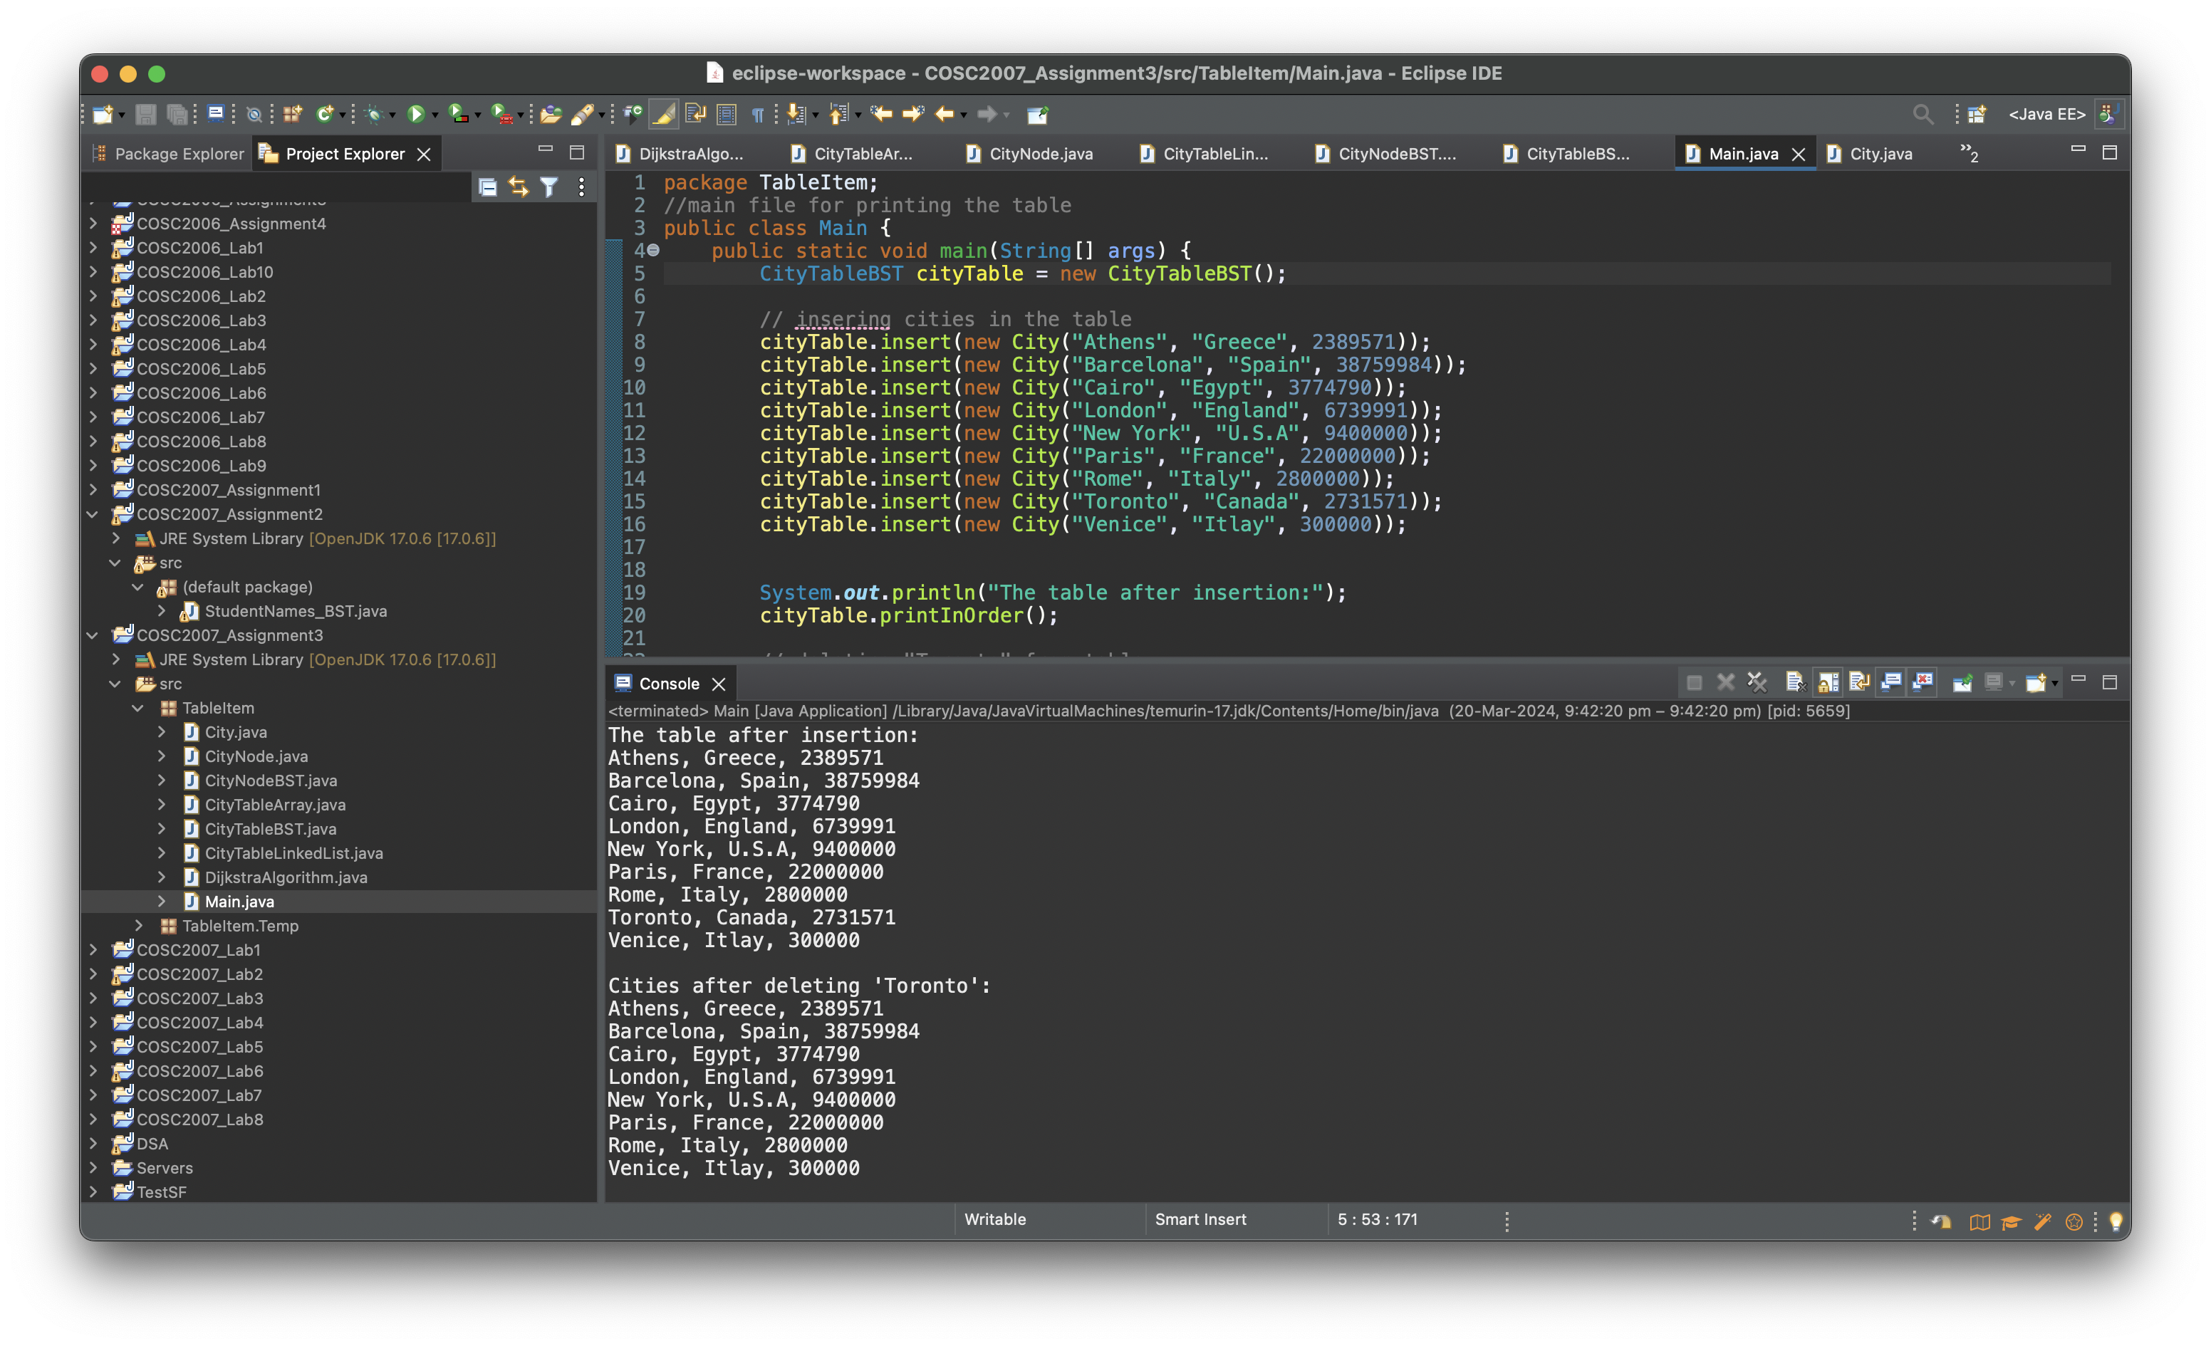

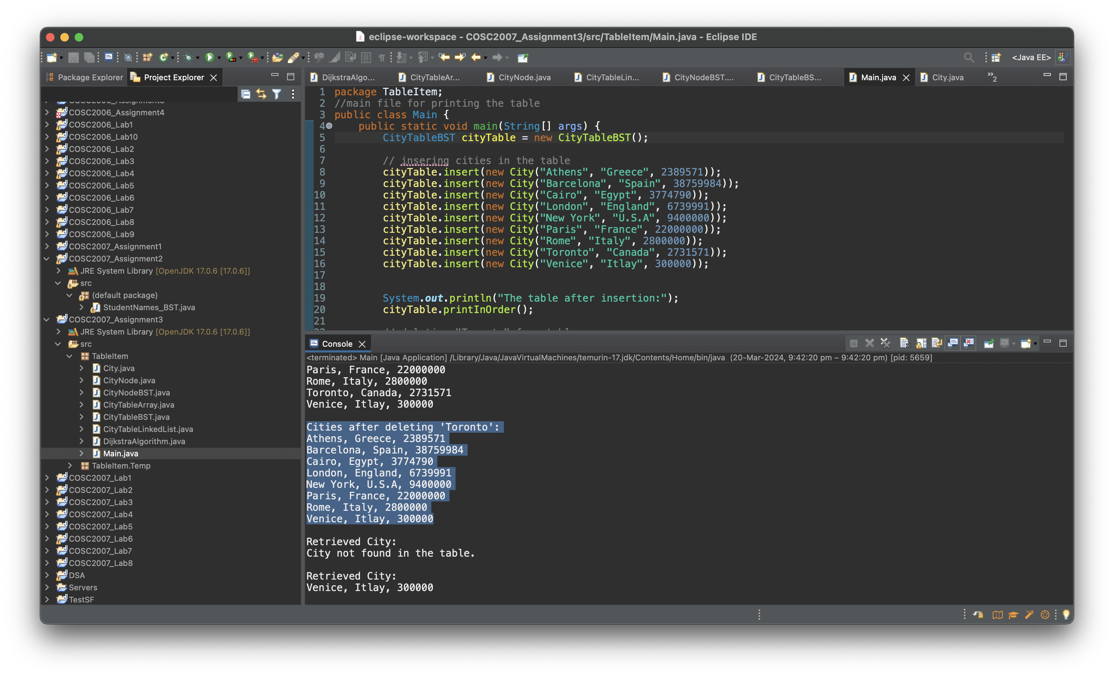

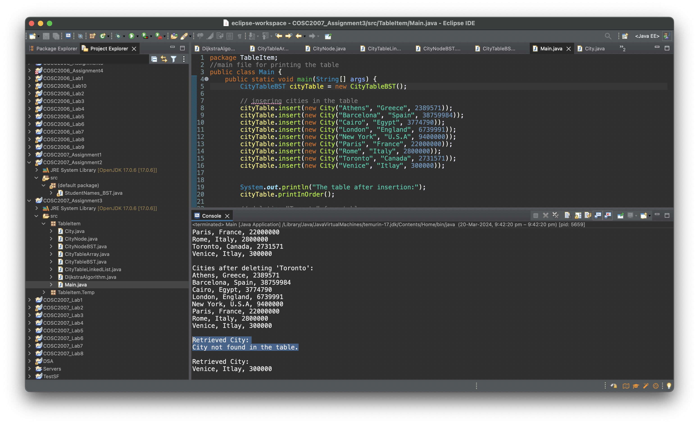

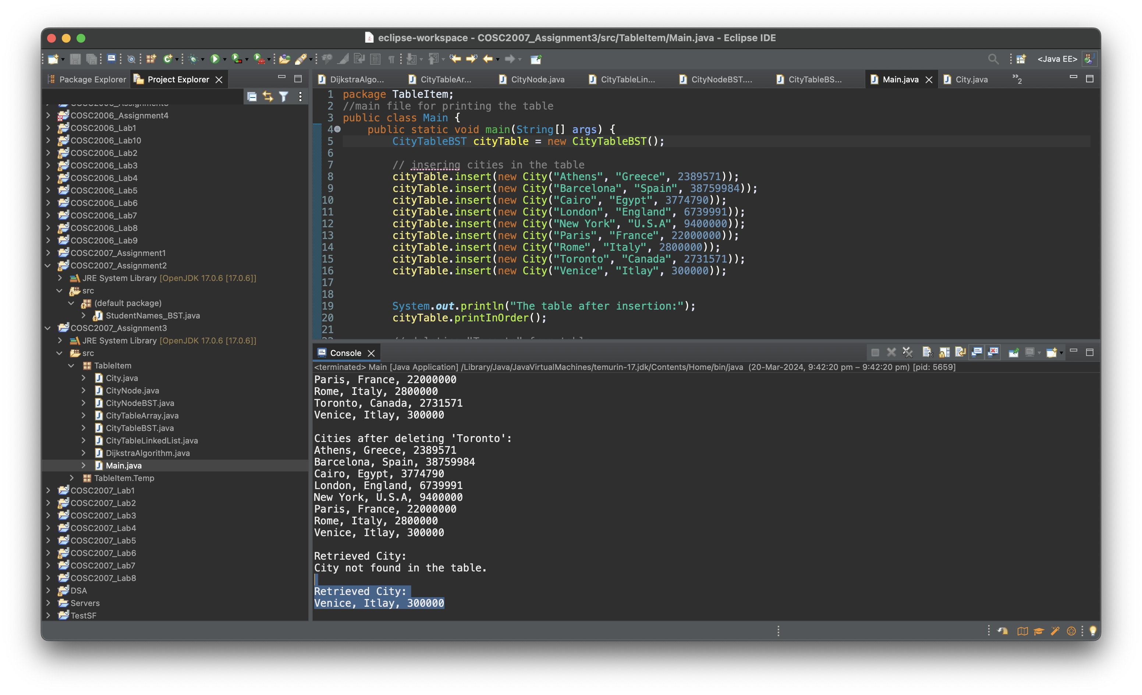

Conclusion:

For the Table ADT, the investigation of Array-based, Reference-based (Linked List), and Binary Search Tree (BST) implementations offered insightful information about choosing data structures according to application requirements. The array-based method has scalability issues but is fast and simple to use. While the BST combines effective search with balanced performance for dynamic operations, making it a flexible option for a variety of use cases, the Linked List performs better in dynamic operations but has slower searches. The significance of selecting the appropriate data structure based on particular requirements, such as operation frequency, data size, and performance criteria, was highlighted by this exercise.

**Exercise No: 2**

**Question: Write the detailed algorithm and convert into Java code for the solution of Dijkstra’s Algorithm. Use the adjacency matrix concept for the graph representation.**

**Algorithm/Pseudocode:**

Algorithm Dijkstra'sAlgorithm(graph, startVertex):

nVertices = number of vertices in graph

Initialize shortestDistances[nVertices]

Initialize added[nVertices]

For each vertex v in graph:

shortestDistances[v] = INFINITY

added[v] = false

shortestDistances[startVertex] = 0

parents[startVertex] = NO_PARENT

For each vertex v in graph except startVertex:

nearestVertex = Find unvisited vertex with smallest known distance from startVertex

added[nearestVertex] = true

For each unvisited neighbor u of nearestVertex:

edgeDistance = graph[nearestVertex][u]

newDistance = shortestDistances[nearestVertex] + edgeDistance

If newDistance < shortestDistances[u]:

shortestDistances[u] = newDistance

parents[u] = nearestVertex

printSolution(startVertex, shortestDistances, parents)

Function printSolution(startVertex, distances, parents):

For each vertex v, starting from startVertex:

Print "startVertex -> v: distance, path"

Function printPath(currentVertex, parents):

If currentVertex has NO_PARENT:

return

Else:

Recursively print path from start vertex to parent of currentVertex

Print currentVertex

**Code:**

package TableItem;

/**

* Name: Jeel Tikiwala

* Student ID: 239659420

* Assignment 3

* Any and all work in this file is my own.

* Exercise 2

*/

public class DijkstraAlgorithm {

private static final int ***NO_PARENT*** = -1;

// Main method(6 vertices)

public static void main(String[] args) {

int graph[][] = new int[][]{

{0, 6, 0, 1, 0, 0, 0},

{6, 0, 5, 2, 2, 0, 0},

{0, 5, 0, 0, 5, 0, 0},

{1, 2, 0, 0, 1, 4, 0},

{0, 2, 5, 1, 0, 0, 3},

{0, 0, 0, 4, 0, 0, 2},

{0, 0, 0, 0, 3, 2, 0}

};

*dijkstraAlgorithm*(graph, 0); // 0 is the source vertex

}

// Function that implements Dijkstra's algorithm

// graph[][]: adjacency matrix representation of the graph

// startVertex: source vertex to find shortest path from

public static void dijkstraAlgorithm(int[][] graph, int startVertex) {

int nVertices = graph[0].length;

// Shortest distances from startVertex to i

int[] shortestDistances = new int[nVertices];

// Added[i] will be true if vertex i is included in shortest path

boolean[] added = new boolean[nVertices];

// Initialize all distances as INFINITE and added[] as false

for (int vertexIndex = 0; vertexIndex < nVertices; vertexIndex++) {

shortestDistances[vertexIndex] = Integer.***MAX_VALUE***;

added[vertexIndex] = false;

}

// Distance of source vertex from itself is always 0

shortestDistances[startVertex] = 0;

// store shortest path tree

int[] parents = new int[nVertices];

// The starting vertex does not have a parent

parents[startVertex] = ***NO_PARENT***;

// to get shortest path for all vertices

for (int i = 1; i < nVertices; i++) {

// min distance vertex from the set of vertices, not yet processed

int nearestVertex = -1;

int shortestDistance = Integer.***MAX_VALUE***;

for (int vertexIndex = 0; vertexIndex < nVertices; vertexIndex++) {

if (!added[vertexIndex] && shortestDistances[vertexIndex] < shortestDistance) {

nearestVertex = vertexIndex;

shortestDistance = shortestDistances[vertexIndex];

}

}

added[nearestVertex] = true;

// Update dist value of the adjacent vertices of the picked vertex.

for (int vertexIndex = 0; vertexIndex < nVertices; vertexIndex++) {

int edgeDistance = graph[nearestVertex][vertexIndex];

if (edgeDistance > 0 && ((shortestDistance + edgeDistance) < shortestDistances[vertexIndex])) {

parents[vertexIndex] = nearestVertex;

shortestDistances[vertexIndex] = shortestDistance + edgeDistance;

}

}

}

*printSolution*(startVertex, shortestDistances, parents);

}

private static void printSolution(int startVertex, int[] distances, int[] parents) {

int nVertices = distances.length;

System.***out***.print("Vertex\t Distance\tPath");

for (int vertexIndex = 0; vertexIndex < nVertices; vertexIndex++) {

if (vertexIndex != startVertex) {

System.***out***.print("\n" + startVertex + " -> ");

System.***out***.print(vertexIndex + " \t\t ");

System.***out***.print(distances[vertexIndex] + "\t\t");

*printPath*(vertexIndex, parents);

}

}

}

// fn to print shortest path from source to currentVertex using parents array

private static void printPath(int currentVertex, int[] parents) {

if (currentVertex == ***NO_PARENT***) {

return;

}

*printPath*(parents[currentVertex], parents);

System.***out***.print(currentVertex + " ");

}

}

**Output:**

**Output -1**

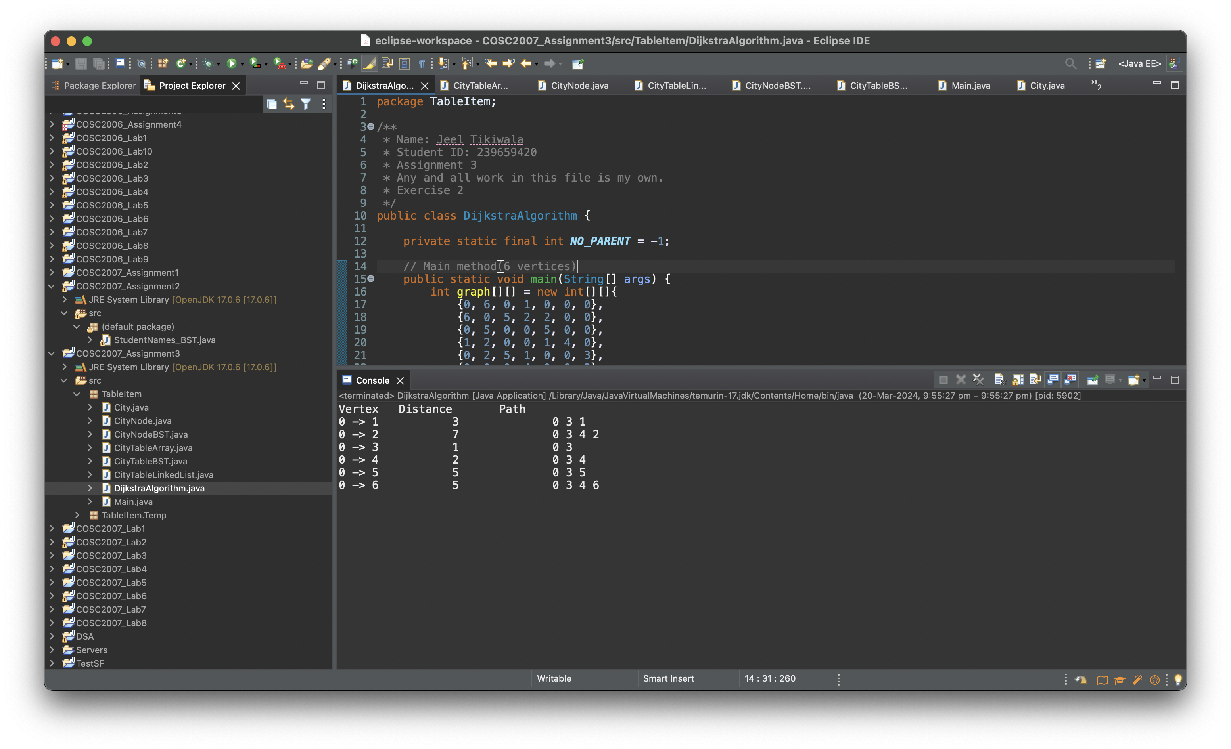

Output - 2

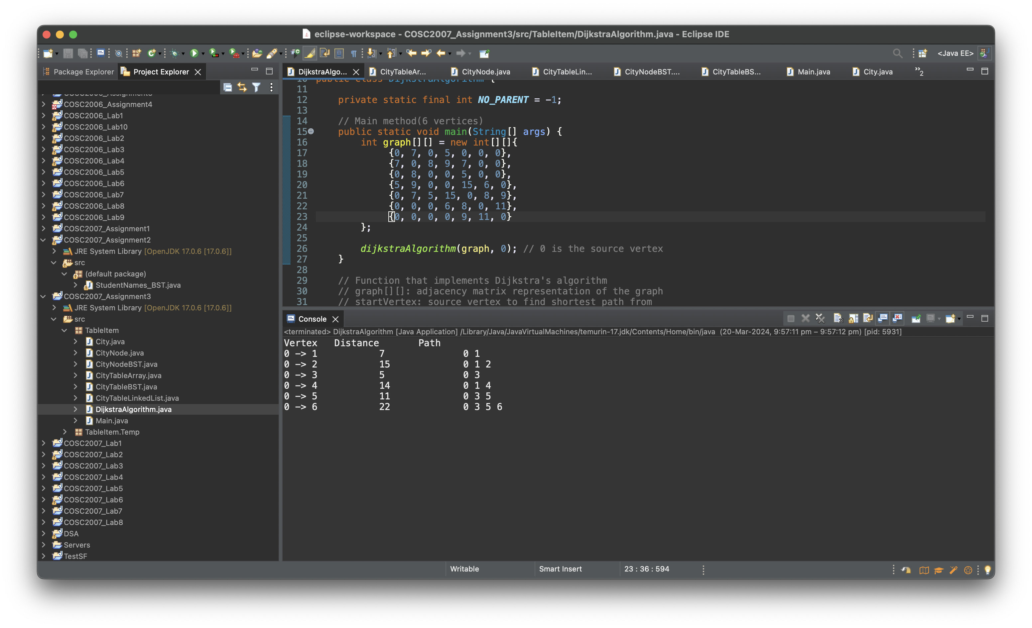

**CONCLUSION:**

Using an adjacency matrix to represent the graph, the Java implementation of Dijkstra's algorithm successfully illustrates how to find the shortest path from a single source vertex to every other vertex in a weighted graph. This method effectively finds the shortest paths in dense graphs where edge weights are non-negative, demonstrating the usefulness and applicability of Dijkstra's algorithm in a variety of optimisation problems, including network routing and geographic mapping. This algorithm highlights the significance of algorithmic strategy in computational problem-solving by managing dynamic graph structures and guaranteeing optimal pathfinding.